

**Carrier 2.5HP A5CK 25E/A5LC 20C**

**Rs. 89,600/-**

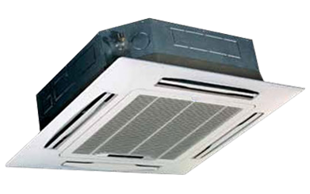

**Product Features**

* concealed LED display
* Intelligent airflow
* precise system control technology
* friendly referigerant R410a
* auto restart after power restored

**Specification**

**Type** Ceiling Cassette AC

**Cooling (Btu/h)** 48000

**Voltage (V)** 220-240

**Power Input (W)** 5600

**EER (Btu/W-h-W/W)** 5.3-2.8